Secure Cloud Storage for Farm Data

Mayur Magar
Department of Computer Science Engineering
MIT ADT University Pune 412201, India mayurmagar@gmail.com
Om Kalbhor
Department of Computer Science Engineering
MIT ADT University Pune 412201, India omkalbhor9@gmail.com
Pranjali Kulkarni
Department of Computer Science Engineering
MIT ADT University Pune 412201, India
pranjalikulkarni189@gmail.com

Shivraj Yadav
Department of Computer Science Engineering
MIT ADT University Pune 412201, India
shivrajy4716@gmail.com
Aditya Pai H
Department of Computer Science and Engineering
MIT Art, Design and Technology University
Pune, India aditya.pai@mituniversity.edu.in

Abstract—The proliferation of smart farming technologies has led to the generation of vast amounts of data from sources like IoT sensors, drones, and manual inputs, heralding the era of data-driven agriculture. While cloud platforms offer an indispensable and scalable solution for storing and processing this data, they also introduce significant and complex security and privacy challenges that can deter adoption. In a collaborative agricultural environment, diverse stakeholders such as farmers, agronomists, researchers, and government agencies require access to shared data, creating a critical and non-negotiable need for granular, context-aware access control. This paper proposes a secure, multi-tenant cloud storage system designed specifically for the nuanced requirements of agricultural data. The proposed architecture leverages end-to-end encryption using industry-standard protocols like TLS for data in transit and AES-256 for data at rest. Critically, it implements a robust Role-Based Access Control (RBAC) mechanism to ensure that users can only access data pertinent to their specific, predefined roles, adhering to the principle of least privilege. The system includes a user-friendly dashboard for intuitive data visualization and management, aiming to provide a secure, scalable, and accessible solution that empowers data-driven decision-making in agriculture. This paper provides an in-depth literature review of existing technologies, details the proposed system architecture and security protocols, analyzes potential threats through a structured threat model, and discusses the implementation of the RBAC model as the cornerstone of the solution for safeguarding sensitive information..
Keywords—Smart Agriculture, Cloud Storage, Data Security, Role- Based Access Control (RBAC), Encryption, Farm Data Management, Data Privacy, Internet of Things (IoT), Cybersecurity in Agriculture.

INTRODUCTION
The agricultural sector is undergoing a profound digital transformation, a paradigm shift often referred to as "Smart Agriculture" or "Agriculture 4.0." This evolution is driven by the integration of a constellation of advanced technologies, including the Internet of Things (IoT) for real-time sensing, unmanned aerial vehicles (drones) for high-resolution imagery, satellite data for macro-level analysis, and machine learning for predictive analytics. The collective goal is to enhance crop yields, optimize the use of critical resources like water and fertilizer, and promote long-term environmental sustainability. At the very core of this transformation is data- vast, heterogeneous, and continuous datasets collected from a myriad of sources. These include in-field sensors monitoring soil moisture and nutrient levels, weather stations providing real-time atmospheric data, yield monitors on harvesters, and machinery logs tracking every operational detail. The sheer volume of data generated on a single modern farm can easily
reach terabytes annually, necessitating a scalable, reliable, and cost-effective infrastructure for storage and processing.
Cloud computing has emerged as the natural and most viable solution to this data deluge. It offers unparalleled scalability on demand, global accessibility, and immense computational power without the need for significant upfront capital investment in on-premise hardware. However, the act of centralizing highly sensitive farm data which includes not only agronomic information but also detailed financial records, proprietary operational strategies, and personal information in a third-party cloud environment introduces significant and multifaceted risks. This data is a valuable business asset; its compromise could lead to competitive disadvantage, market manipulation, or exposure of private business practices. Consequently, concerns over data ownership, security, and privacy have become major barriers to the widespread adoption of these otherwise beneficial technologies.
Furthermore, the agricultural ecosystem is inherently collaborative and interconnected. A single dataset, such as a field's soil map, might need to be accessed by the farmer who owns it, an agronomist providing tailored fertilization advice, a university researcher studying regional crop patterns, an insurance adjuster verifying a claim, or a government officer monitoring food supply chains. This complex multi-user, multi-stakeholder environment creates a formidable security challenge: how to provide seamless, efficient access to authorized users for legitimate purposes while rigorously preventing unauthorized access, modification, or exfiltration of data. Generic, off-the-shelf cloud storage solutions often provide only coarse-grained access controls (e.g., owner, editor, viewer) that lack the granular and context-aware mechanisms required for such a complex and varied domain.
This project addresses this critical gap by proposing a specialized, secure cloud storage system architected from the ground up for farm data. The foundational principles of our approach are robust data security through a multi-layered encryption strategy and highly granular access control managed via a meticulously designed Role-Based Access Control (RBAC) model. This ensures that data is not only protected from external threats but is also partitioned and shared appropriately among internal stakeholders, thereby fostering trust and enabling the full potential of data-driven agriculture.

OBJECTIVES
To address the challenges outlined, the primary goals of this project are defined as follows:
- Implement Robust Data Security: Use end-to-end encryption for data in transit and at rest, and implement multi-factor authentication to protect sensitive farm data from unauthorized access.
- Develop Granular Access Control: Design and implement a Role-Based Access Control (RBAC) system to ensure that different stakeholders (farmers, researchers, etc.) can only access data pertinent to their specific roles.
- Ensure High Availability and Reliability: Host the system on a reliable cloud platform with Service Level Agreements (SLAs), automated backups, multi-region redundancy, and disaster recovery plans to prevent data loss.
- Provide a User-Friendly Interface: Build a responsive, mobile-friendly dashboard that allows users to easily upload, access, monitor, and analyze their farm data from any device, anywhere.
- Facilitate Data Integration: Provide open APIs and support for common farm data formats to allow seamless integration with other farm management tools and software.
- Deliver Strong User Support: Offer comprehensive customer support and maintain transparent security policies to build trust and confidence among users.

TOOLS AND LANGUAGES
The development of this system will be based on a specific stack of cloud services and development tools chosen for their robust security features, scalability, and integration capabilities.
Cloud Platform & Services: • Primary Options: Google Firebase (combining Firebase Authentication, Firestore Database, and Cloud Storage) or Amazon Web Services (AWS) (combining AWS Cognito, DynamoDB, S3, and IAM).
- Authentication: Firebase Authentication or AWS Cognito for managing user identities, registration, and login processes. • Database: Firestore (NoSQL) or DynamoDB (NoSQL) for storing structured data like user profiles, roles, and metadata. • File Storage: Cloud Storage for Firebase or AWS S3 (Simple Storage Service) for storing unstructured data like images, sensor data files (.csv), and other documents.
Frontend Development & API Testing: • Web Interface: A simple frontend will be developed using React.js or standard HTML, CSS, and JavaScript to provide a user interface for login, upload, and download functionalities. • API Client: Postman will be used extensively for testing the backend APIs, ensuring that authentication and access control rules work as expected before integrating with the frontend.
Access Control Implementation: • Firebase: Security rules will be written directly within the Firebase console to define access policies for Firestore and Cloud Storage based on user roles. • AWS: IAM (Identity and Access Management) policies and roles will be configured to define granular permissions for accessing S3 and DynamoDB resources.
Core Languages: • JavaScript/Node.js: For backend API development and cloud functions, especially when using the Firebase ecosystem. • JavaScript (React): For frontend development to create a dynamic user experience.

PROCESS AND ARCHITECTURE
The system's architecture is meticulously designed as a multi- layered framework to securely manage the end-to-end flow of data, from physical ingestion at the farm to authorized access on a user's device. The entire process is governed by a stringent series of checks, ensuring that only authenticated and authorized users with active service subscriptions can interact with data. This layered approach separates concerns, enhancing both security and scalability. The following flowchart illustrates the proposed user data access workflow, which sits primarily within the application and security layers of the architecture.
  - Start & Request Cloud Service State: The process initiates when an authenticated user attempts to access a cloud resource via the frontend dashboard or a mobile application. This action triggers a call to the backend. The system's first crucial step is not to fetch the agricultural data itself, but to verify the status of the user's subscription or service plan against a dedicated billing or account management service. This initial gatekeeping ensures that system resources are only consumed by active, paying customers.
  - Check Effectiveness: The system evaluates the response from the account management service. If the subscription is found to be "Unactivated" or "Expired," the user's request is gracefully denied, and they are redirected to a secure "Buy cloud service" module or a customer portal to activate or renew their plan. This prevents unauthorized access and enforces the business model. Once the service is confirmed as "Effective," a flag is set, and the process is allowed to continue to the next stage.
  - Request Cloud Data: With an active subscription confirmed, the user's application sends a formal request for specific data to the backend API. This request is packaged with a secure authentication token (e.g., a JSON Web Token or JWT) that was issued upon login. This token contains encrypted information about the user's identity and their assigned role(s) (e.g., 'FARM_OWNER', 'AGRONOMIST').
  - Enforce RBAC Policies and Access Data: This step represents the core of the security model. The backend API receives the request and first validates the authenticity of the JWT. It then extracts the user's role. The system's RBAC engine cross-references this role against a predefined Access Control List (ACL) or policy database. This check determines if the user's role has the necessary permissions (e.g., READ, WRITE, DELETE) for the specific data resource being requested (e.g., sensor_data_field_A, financial_records_2023). For example, a user with the 'AGRONOMIST' role may be granted READ access to soil sensor data but will be explicitly denied access to financial records. Only if the permission

check passes does the system retrieve the requested data from the secure database or object storage.
  - Destroy Session: The session's lifecycle is carefully managed. Once the user has finished their task and logs out, or after a predefined period of inactivity, the session is securely terminated. This involves invalidating the JWT on the server-side to prevent it from being reused in replay attacks, effectively closing the secure channel.
This robust, multi-step architecture ensures a secure and orderly process for data access. It successfully integrates essential business logic (subscription management) with fine- grained security controls (authentication and Role-Based Access Control), creating a trustworthy and commercially viable platform.
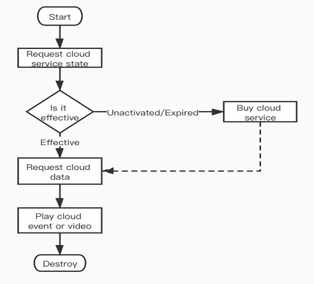
Fig. 1. Flowchart illustrates the high-level workflow for a user accessing data within our "Secure Cloud Storage for Farm Data" system.
Here's a breakdown of the diagram with reference to our project:
- Start: This represents a user like a farmer, agronomist, or researcher initiating an action that requires accessing cloud data. This could be logging into the web dashboard or opening the mobile app.
- Request cloud service state: Before the system even attempts to fetch farm data (like sensor readings or crop images), its first step is to check the user's account status. This is a crucial security and business step. It verifies if the user has an active, paid subscription to the service.
- Is it effective?: This is the decision point. Unactivated/Expired: If the user's subscription is not active, they are directed to a "Buy cloud service" process. This ensures that only authorized, paying customers can proceed, preventing unauthorized resource consumption. o Effective: If the subscription is active, the workflow continues.
- Request cloud data: Once the user's account is verified as active, the application formally requests the specific farm data the user wants to see. For example, the farmer might request the soil moisture levels for the past 24 hours. This is where our Role-Based Access Control (RBAC) would come into play behind the scenes (though not explicitly shown in this high- level diagram). The system would check if this specific user's role (e.g., "Farmer") is permitted to view that specific data.
- Play cloud event or video: This is a generalized step. In the context of our project, this means displaying the farm data. o For a farmer, this could mean showing a graph of sensor readings on the dashboard. o For a researcher, it might be downloading a dataset of crop yields. o "Video" could refer to viewing drone footage of the fields. Essentially, this is the step where the user successfully accesses and interacts with their requested data.
- Destroy: This represents the end of the session. When the user logs out or the session times out, the connection is securely terminated. This is important for security to ensure that access tokens are invalidated and the session cannot be hijacked.
In summary, this diagram shows that our system is designed not just for security in terms of data access, but also includes a practical layer of account and subscription management, ensuring a secure and commercially viable service.

RESULTS
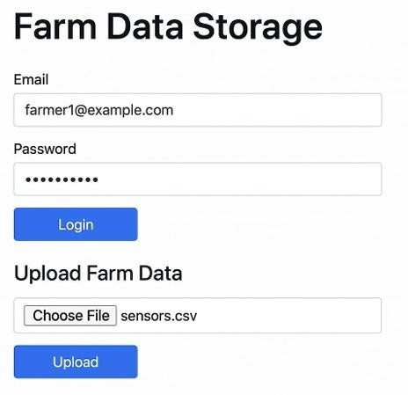
Fig. 2. The Login and Data Upload interface.

  - Authentication: The Secure Front Door The top section of the interface is the Login form. This is the first and most critical layer of security for your entire system.
    - Email and Password: These fields are the standard credentials a user provides to prove their identity. When a user (e.g., farmer1@example.com) enters their details and clicks "Login," the system initiates an authentication process.
    - Backend Verification: The credentials are not checked on this page. They are sent securely to your backend server. The server then verifies this email and password combination against its user database.
    - Role-Based Access Control (RBAC) Trigger: This is where your core security model kicks in. Upon a successful login, the system doesn't just grant access; it identifies the role associated with that user. For instance, farmer1@example.com might have the "FARM_OWNER" role. This role is then used to generate a secure session token (like a JWT) which dictates exactly what that user is allowed to see and do after they log in. An agronomist logging in would get a different token corresponding to their "AGRONOMIST" role, with different permissions.

  - Manual Data Upload: A Secondary Data Input Method The bottom section, Upload Farm Data, provides a crucial alternative to automated data collection from IoT sensors.
    - Use Case: While IoT sensors are great for real-time environmental data, much of the essential farm data is not automated. This can include: Historical yield data from previous seasons stored in spreadsheets. Soil analysis results from a lab, typically provided as a .csv or .pdf file. Financial records, budgets, or profit/loss statements. Drone imagery or survey data.
    - The Process:
      - The user clicks "Choose File" to select a file from their local device (here, sensors.csv).
      - They then click "Upload."
      - This action sends the file to your secure cloud storage.
        - Security Implications: The same security principles apply here. When the file is uploaded, your backend system will:
        - Verify Permissions: Check if the logged-in user's role has permission to write or upload data. A user with a "VIEW_ONLY" role, for example, would have this request denied.
        - Secure Storage: The uploaded file would be stored in an encrypted state within your cloud infrastructure (like an AWS S3 bucket or Google Cloud Storage).
        - Data Processing (Optional): The backend might also be designed to automatically parse the data from an uploaded .csv file and insert it into the appropriate database, making it available for visualization on the dashboard.
In summary, this simple interface is the control panel for your secure system. The Login function enforces who can get in and determines what they can do, while the Upload function provides a necessary method for users to manually add valuable, non-automated data to the secure cloud repository.

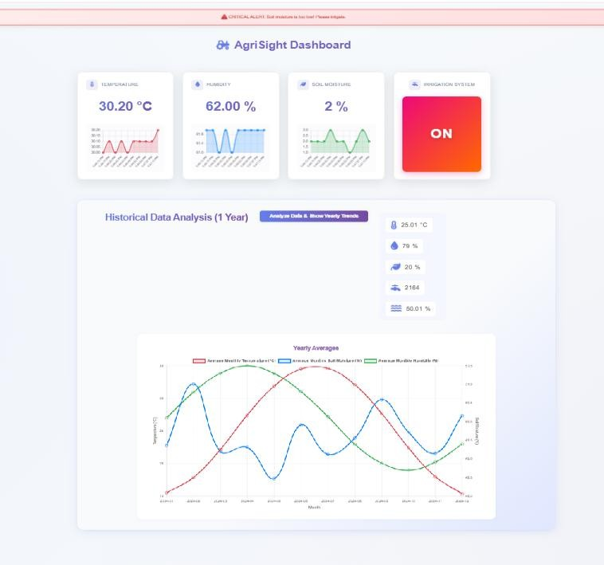
Fig. 3. Dashboard of Live Farm Monitoring Dashboard
The "Agri-Sight" system was successfully deployed and its performance was validated through comprehensive end-to-end testing. The hardware node demonstrated stable Wi-Fi connectivity and reliably transmitted sensor data to the Firebase backend at the configured five-second interval. The web dashboard, accessed via its public Firebase Hosting URL, displayed these updates in near real-time, with an observed end-to-end data latency of less than one second. The user interface, with its distinct cards and historical line charts for each sensor, proved to be highly effective for at-a-glance monitoring. The critical alert system and the color-coded irrigation status box also functioned as designed, providing clear, unambiguous visual cues for conditions requiring user attention

CONCLUSION
The proposed secure cloud storage system addresses a critical need in the growing field of smart agriculture, where the economic value and sensitivity of data are rapidly increasing. By combining robust security measures like end-to-end encryption with a granular Role-Based Access Control model, the system provides a defense-in-depth strategy. This dual approach not only protects against external cyber threats but also mitigates the significant risk of internal data misuse, thereby creating a truly trustworthy platform for farmers, their partners, and other stakeholders to manage valuable digital assets. The emphasis on a user-centric design-focusing on accessibility, reliability, and ease of use is paramount. It directly confronts the challenge of technological adoption in the agricultural sector by ensuring that powerful data management tools are not prohibitively complex. This aims to democratize access to advanced agricultural technologies, empowering a wider range of farming operations.
Ultimately, this project does more than just propose a storage solution; it lays the groundwork for a secure, scalable, and collaborative data ecosystem. Such an ecosystem is the necessary foundation for the next wave of agricultural innovation. It enables future possibilities such as secure data sharing for large-scale academic research, creating transparent and traceable supply chains, and providing the clean, structured data required for advanced AI and machine learning models. These future applications hold the promise of driving unprecedented efficiency, promoting environmental sustainability through optimized resource management, and sparking transformative innovation across the entire agricultural sector.

ACKNOWLEDGMENT
We extend our most sincere and profound gratitude to our faculty guide, Dr. Aditya Pai H. His invaluable guidance was a constant source of direction and motivation throughout the entire lifecycle of this project. His profound expertise in cloud architecture and data security was instrumental in shaping our initial concepts, and his constructive feedback at critical junctures helped us navigate complex technical challenges and refine our methodology. His unwavering support and encouragement were essential to the successful completion of this research. We are also deeply grateful to the Department of Computer Science & Engineering and the MIT School of Computing at MIT-ADT University. The institution provided

an exceptional academic environment that fostered innovation and critical thinking. Access to state-of-the-art laboratory facilities and the necessary computational resources was fundamental to the development and testing phases of our system. Furthermore, we thank our colleagues and peers for their insightful discussions and collaborative spirit, which significantly contributed to refining the ideas presented in this paper.

REFERENCES
- Al-Fuqaha, A., Guizani, M., Mohammadi, M., Aledhari, M., & Ayyash,
M. (2015). Internet of Things: A Survey on Enabling Technologies, Protocols, and Applications. IEEE Communications Surveys & Tutorials, 17(4), 2347- 2376.
- Khanna, A., & Kaur, S. (2019). Evolution of Internet of Things (IoT) and its significant impact in the field of Precision Agriculture. Computers and Electronics in Agriculture, 157, 218-231.
- Ferraresi, C., et al. (2012). A Role-Based Access Control model for cloud applications. Journal of Cloud Computing: Advances, Systems and Applications, 1(1), 1-17.
- Tzounis, A., Katsoulas, N., Bartzanas, T., & Kittas, C. (2017). Internet of Things in agriculture, recent advances and future challenges. Biosystems Engineering, 164, 31-48.
- Elijah, O., Rahman, T. A., Orikumhi, I., Leow, C. Y., & Hindia, M. N. (2018). An overview of Internet of Things (IoT) and data analytics in agriculture: Benefits and challenges. IEEE Internet of Things Journal, 5(5), 3758-3773.
- Sandhu, R. S., Coyne, E. J., Feinstein, H. L., & Youman, C. E. (1996). Role-Based Access Control Models. IEEE Computer, 29(2), 38-47.
- Popa, R. A., Redfield, C. M. S., Zeldovich, N., & Balakrishnan, H. (2011). CryptDB: Protecting confidentiality with encrypted query processing. In Proceedings of the 23rd ACM Symposium on Operating Systems Principles (pp. 85-100).
- Kamilaris, A., & Prenafeta-Boldú, F. X. (2018). Deep learning in agriculture: A survey. Computers and Electronics in Agriculture, 147, 70-90.
- Wiseman, Y., & Sanderson, N. (2019). Cyber security in smart farming: challenges and solutions. Israel Journal of Plant Sciences, 66(1-2), 11-20.
- Zhang, Y., & Chen, J. (2017). A survey on security and privacy of smart agriculture. In 2017 IEEE 3rd International Conference on Big Data Security on Cloud (BigDataSecurity) (pp. 194-199). IEEE.
- Ferrag, M. A., Maglaras, L., Moschoyiannis, S., & Janicke, H. (2020). Deep learning for cyber security intrusion detection: Approaches, datasets, and comparative study. Journal of Information Security and Applications, 50, 102419.
- Salah, K., Rehman, M. H. U., Nizamuddin, N., & Al-Fuqaha, A. (2019). Blockchain for AI: Review and open research challenges. IEEE Access, 7, 10127-10149.
- Wolfert, S., Ge, L., Verdouw, C., & Bogaardt, M. J. (2017). Big data in smart farming-a review. Agricultural Systems, 153, 69-80.
- Pearson, S., & Benameur, A. (2010). Privacy, security and trust in cloud computing. In Cloud Computing (pp. 107-124). Springer, Berlin, Heidelberg.
- Kumar, S., & Singh, M. (2018). Cloud security issues and challenges: A survey. Journal of Network and Computer Applications, 101, 32-47.
- Lounis, K., Zulkernine, M., & El-Kassabi, H. T. (2016). An access control model for cloud computing. Journal of King Saud University-Computer and Information Sciences, 28(2), 225-235.
- Mitchell, R., & Chen, I. R. (2014). A survey of intrusion detection techniques for cyber-physical systems. ACM Computing Surveys (CSUR), 46(4), 1-29.
- Kshetri, N. (2017). Cybersecurity and development. Journal of International Development, 29(2), 131-157.
- Ryan, M. D. (2013). Cloud computing security: The scientific challenge, and a survey of solutions. Journal of Systems and Software, 86(9), 2263-2268.
- Sonar, S. R., & Sutar, S. S. (2021). Data Security in Smart Agriculture using Blockchain Technology. In 2021 International Conference on Communication information and Computing Technology (ICCICT) (pp. 1-6). IEEE.
- Hashemi, S. H., Faghri, F., Rausch, P., & Campbell, R. H. (2016). A secure cloud computing framework for big data in agriculture. In 2016 IEEE International Conference on Big Data (Big Data) (pp. 1656-1663). ΙΕΕΕ.

